Geometry: Unit 6, Lesson 1
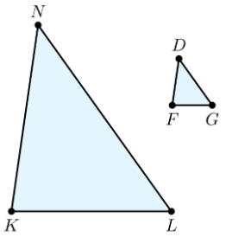
- Triangle $DFG$ is the result of a dilation of triangle $NKL$. $NK=21$, $KL=18$, $NL=25$, $DF=8.4$, $FG=7.2$, and $DG=10$. The scale factor of triangle $NKL$ to triangle $DFG$ is what?

$$\frac{2}{5}$$

- Quadrilateral $PFGH$ was created by dilating quadrilateral $MBGK$. If the length of $MB=4.2$ and the scale factor is $3$, what is the length of the corresponding side, $PF$?

$$12.6$$
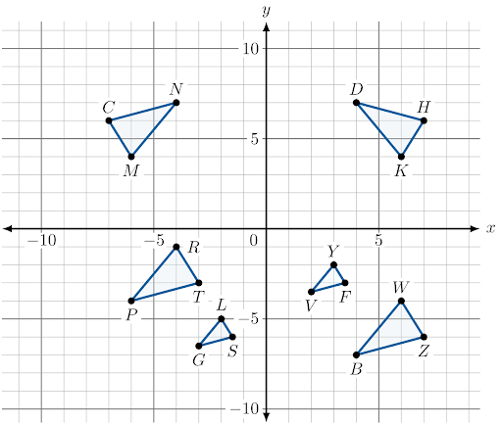
- Triangles $HKD$, $CMN$, $SLG$, $TRP$, and $FYV$ are transformations of $∆ZWB$. What is an example of a pair of triangles that represents rigid transformations of $∆ZWB$?

$∆CMN$ and $∆HKD$

